CV Screening:
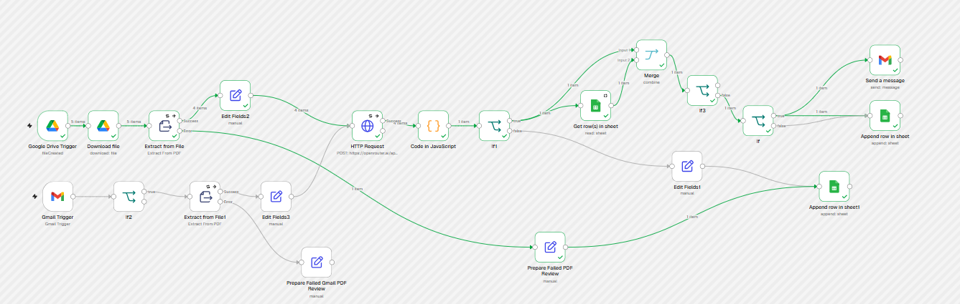

CV Screening Error Handler
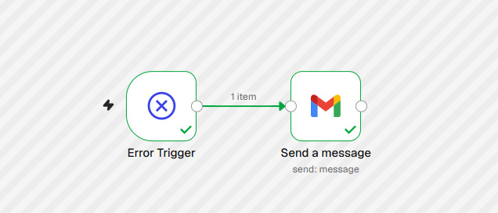
Mini Zapier Workflow:
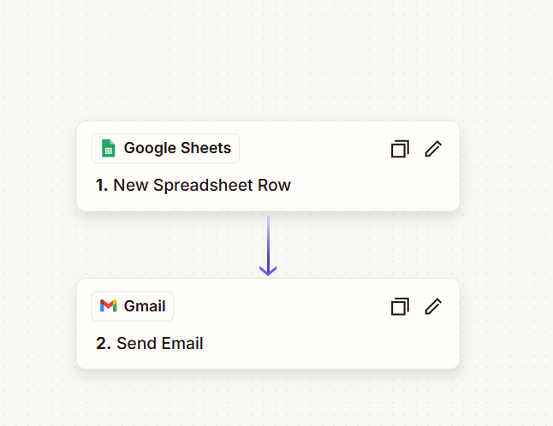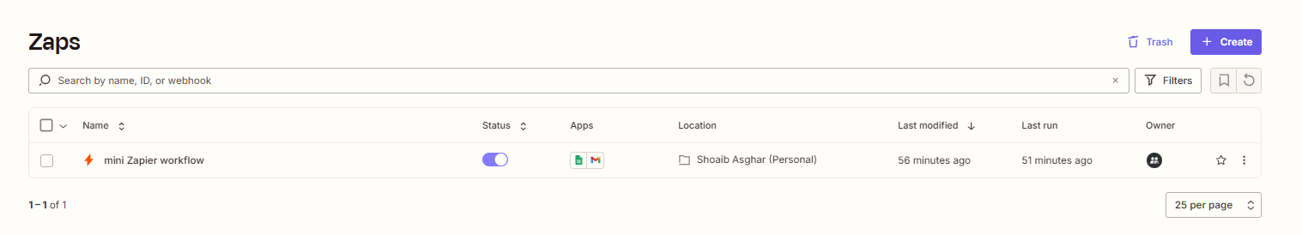
Smart Extractor - FastAPI Integration:


